OCR A Level PE H555 Summer Work 2022
Congratulations on joing our A Level PE course!
The following tasks are designed to get you thinking about our course, content and how you will be assessed during it.
We look forward to working hard with you in September.
Have a great summer!
Please send on all completed work to r.moxon@tuptonhall.org.uk

Learner Task 1
OCR’s A Level in Physical Education (H555)
Please locate the OCR exam specification for our A level course. Download a copy of it and then please print it out and set up your own A level PE folder.
Learner Task: Now spend some time familiarising yourself with the exam specification in order to complete the following questions.
Answer the following questions….
Question 1 How many exams will you take at the end of the course?
Question 2 What are the weightings/percentages for each paper?
Question 3 What % are the Non Examined Assessments in the A Level PE worth as part of your final grade?
Question 4 What is topic title for the following chapters: 1.1a 1.2 2.1?
Question 5 How many different sports are allowed to be used for this A level?
Question 6 What is your main sport….is it on the list?

Learner Task 2
Self Analysis Task
Watch this clip: https://www.youtube.com/watch?v=DxvGC4AeoWI&feature=youtu.be
Analysing sport is a crucial part of the course. I want you to have a go at analysing yourself!
Using the ‘Self Review’ template imagine that you have just observed yourself in your favoured sporting activity.
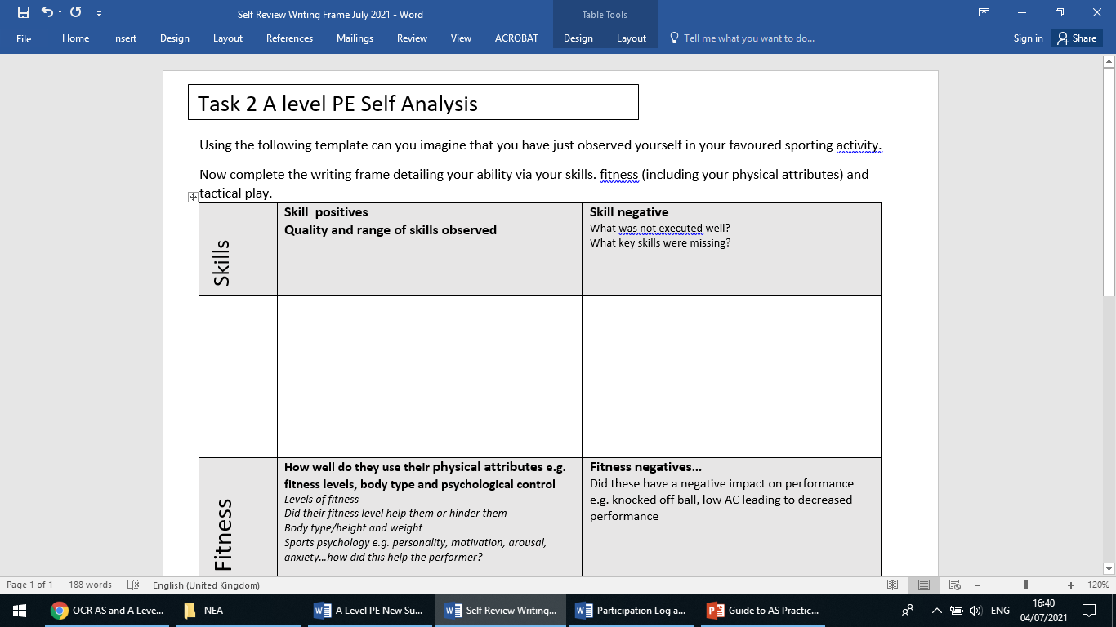
Now complete the writing frame detailing your ability by telling us about your levels of skill. fitness (including your physical attributes) and tactical understanding of your sport. Try to add a couple of strengths and weaknesses for each area.

Learner Task 3 Practical performance
We are keen to know a little bit more about you in terms of your practical ability in your specialist sport in which you intend to use for this A Level.
Complete the Practical Assessment Grid below including grading yourself A B C D or E for your chosen sport.
Sport
Position
League/standard/County
Practical NEA Sport A level Assessment Grid
Level | Range skills | Quality skills | Physical  Attributes | Decision  Making | Effective  Performance | Overall  Grade
6
5
4
3
2
1
0
Grade yourself
A-E

Final Learner Task
Use the blank body image to label the following muscles.

